Student Activity Worksheet 1
Created by Ken Gothman
Revised: 1-22-20

Name: _____________________________________
Date: ______________________ Hour: ________
Login to Xello using your school’s Xello link
or go to xello.world and use your school email address as your username. If you don’t remember your password, you can click on “Having Trouble Signing in” and you will be directed to reset your password.

If prompted to add a personal email address, please do so, as this will allow you to continue to use your Xello account after you have graduated from high school.

- Phase 1: Under the “About Me” section on the left, click on the ”Matchmaker” Get Started button. Read the introduction and then click on the Launch Matchmaker! button.

For “What would you like to do after high school”, click on Not Sure Yet (You can change this later)
Then click on the button.

ANSWER THE QUESTIONS BASED ON WHAT YOU ENJOY DOING RATHER THAN WHAT YOU ARE GOOD AT.

When you finish the “Matchmaker” questions, don’t look at the career matches yet.

- Instead, go right to “Phase 2: Your Personality Style” and click on Start the Quiz

Read the introduction, then click on Ready! to begin and answer questions.

Circle which of the following personality style(s) that Xello indicates that you have:
Builder Thinker Creator Helper Persuader Organizer

Carefully read the information about your personality style and then click on Done at the top right.
Click on the Logo at the top left corner to return to the Xello home page.

- Phase 3: Click on the “Mission Complete” Get Started button.
Read the intro. Then click on Let’s go!

When you are finished with “Mission Complete,” click on View My Matches

- CAREER EXPLORATION: Click on the various top 40 careers that were matched to you and begin to read about them. Take time to especially read all about careers that you don’t know much about.

- SAVING CAREERS OF INTEREST
When you find a Career that you are interested in possibly doing, save it.
You can do this by clicking on the heart, which will turn it red.

***Find at least 5 careers that you like the most and SAVE them. ***

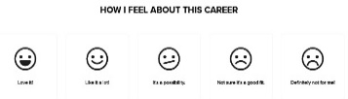
- For each of your 5 favorite careers that you saved, scroll back

up to the top and select how you feel about each of them.

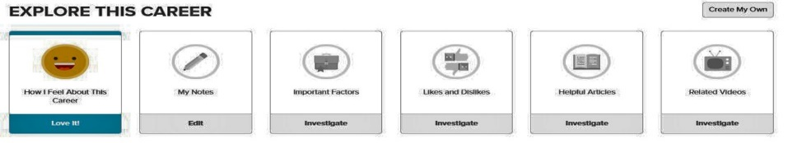
Student Activity Worksheet 1 – Continued…
- Then, click on “Explore This Career”.

and complete the first 4 sections.

- RANKING YOUR CAREERS OF INTEREST
Once you have finished exploring all of the top 40 careers and have saved
least 5 careers, click on the heart at the top left to see the ones you’ve saved.

- Rank YOUR top 5 career choices in the order you consider most interesting (1) to less interesting (5). 1 _______________________________________ 2 ________________________________________
3 __________________________ 4 __________________________ 5 ________________________

- THINKING MORE ABOUT IT. Click on the career that is YOUR # 1 FAVORITE CHOICE (except for Professional Athlete or any Military Careers. Choose a different favorite career instead for the next activities.)

Under the “Explore This Career” section, click on the
“Important Factor – Investigate” button and answer the 6 questions.

Scroll down and carefully READ the “Job Description” and “Working Conditions” sections.
Based on what you read in the Job Description and Working Conditions,
Write down 3 things you like about this job.
1 __________________________ 2 _________________________ 3 _________________________
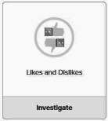
Write at least 1 thing you dislike about this job.
1 _________________________________________________________________________
Click on the “Likes & Dislikes – Investigate” button and type in the answers you wrote above.

- Circle here which demand level is indicated for this career. High Increasing Stable Declining

- Scroll down to “Earnings.” Carefully read the information.

Click on “Salary.” What is the Median yearly salary for this career? $__________________ per year.

- Scroll down to “Education & Training.” Carefully read the information.
Describe what type of education or training is typically needed for this career? ___________________
____________________________________________________________________________________

- Look at “Related Majors” click on, read about, and save the program majors that sound interesting to you? Click on and write here the major you are most interested in: ___________________________

- Scroll down, then write here which COLLEGE you are most interested in? _______________________ Click on that college and read about it.

- Scroll to “Applying.” What is the average high school GPA? _____ What is the acceptance rate? ____%

- Scroll below “SAT Score” to “Admissions Factors” and click on it. List 3 things that may be considered to get accepted at this college: 1 __________________ 2 _________________ 3 ________________

- Scroll down to “Paying.” Click on “In State.” Fill in the amounts below:
Expenses Subtotal $ _____________ Estimated Financial Aid $ ____________ Total $ ____________
- Go back and click on at least 2 colleges that you are interested in possibly
attending and save them by clicking on the heart.

